JAYARATHNE K.P.S.U

IT24103553

Probability and Statistics

1. A train arrives at a station uniformly between 8:00 a.m. and 8:40 a.m. Let the random variable X represent the number of minutes the train arrives after 8:00 a.m. What is the probability that the train arrives between 8:10 a.m. and 8:25 a.m.?

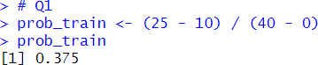

1. The time (in hours) to complete a software update is exponentially distributed with rate λ = 1 3 . Find the probability that an update will take at most 2 hours.

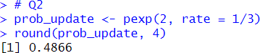

1. Suppose IQ scores are normally distributed with a mean of 100 and a standard deviation of 15.
   1. What is the probability that a randomly selected person has an IQ above 130?
   2. What IQ score represents the 95th percentile?

